1.what is docker compose?
Sol: It is a YAML file consisting of all the details regarding various services, networks, and volumes that are needed for setting up the Docker-based application. So, docker compose is used for creating multiple containers, host them and establish
communication between them. For the purpose of communication amongst the
containers, ports are exposed by each and every container.
2.what is def in Jenkins function?
Ans: - defines variable.
3.shell scripting question?
4. What is difference between docker copy and add?
Ans: - Docker COPY takes in a source and destination. It only lets you copy in a local or directory from your host (the machine-building the Docker image) into the Docker image itself. ADD lets you do that too, but it also supports 2 other sources. First, you can use a URL instead of a local file/directory
5.jenkins parameter plugins scenario?
Ans: normal Jenkins pipeline build process along with installing parameter plugin
6.jenkins pipeline from scratch?
Ans: no I haven’t done in my environment.
7.jenkins cli

8.how u remove data in commit id in git?

Ans: Example git log
Number | Hash | Commit Message | Author
1 | 2c6a45b | (HEAD) Adding public method to access protected method | Tom
2 | ae45fab | Updates to database interface | Contractor 1
3 | 77b9b82 | Improving database interface | Contractor 2
4 | 3c9093c | Merged develop branch into master | Tom
5 | b3d92c5 | Adding new Event CMS Module | Paul
6 | 7feddbb | Adding CMS class and files | Tom
7 | a809379 | Adding project to Git | Tom
Using Rebase
Using the git log above we want to remove the following commits; 2 & 3 (ae45fab & 77b9b82). As they are consecutive commits we can use rebase.
git rebase --onto <branch name>~<first commit number to remove> <branch name>~<first commit to be kept> <branch name>
e.g to remove commits 2 & 3 above
git rebase --onto repair~3 repair~1 repair
Using Cherry Pick
Step 1: Find the commit before the commit you want to remove git log
Step 2: Checkout that commit git checkout <commit hash>
Step 3: Make a new branch using your current checkout commit git checkout -b <new branch>
Step 4: Now you need to add the commit after the removed commit git cherry-pick <commit hash>
Step 5: Now repeat Step 4 for all other commits you want to keep.
Step 6: Once all commits have been added to your new branch and have been commited. Check that everything is in the correct state and working as intended. Double check everything has been commited: git status
Step 7: Switch to your broken branch git checkout <broken branch>
Step 8: Now perform a hard reset on the broken branch to the commit prior to the one your want to remove git reset --hard <commit hash>
Step 9: Merge your fixed branch into this branch git merge <branch name>
Step 10: Push the merged changes back to origin. WARNING: This will overwrite the remote repo! git push --force origin <branch name>
You can do the process without creating a new branch by replacing Step 2 & 3 with Step 8 then not carry out Step 7 & 9.

9.how, you copy file in linux?
Ans: cp filename
10. how u integrate web server in aws?
Ans: create ec2 instance and install apache web server
11.how u create multiple branches in git ?
Ans: by using worktree feature in Git.
12. what is the purpose of Jenkins home directory?
Ans: it contains all Jenkins info like target directory, xml file etc.. in it.

Quest Global interview questions:
13. Jenkins xml file related
14. how u build in Jenkins?
Ans:
1. Login ton Jenkins
2. click new item
3. give name for new item
4. select freestyle project.
5. Configure with required settings like taking source code from Git etc..
15. what is virtualization? In docker?
Ans: Docker is basically using the OS-level virtualization, Linux namespaces and control groups, for example. Its overhead is very thin compared to a virtualization technique, like Hypervisor used by virtual machines

16. how many docker components are there?
Ans: There are three parts to the Docker Engine: Server: The Docker daemon (dockerd) is in charge of creating and managing containers. Rest API: The Rest API enables the communication between applications and Docker and gives Dockerd instructions. Command Line Interface (CLI): Docker commands are executed using the CLI.
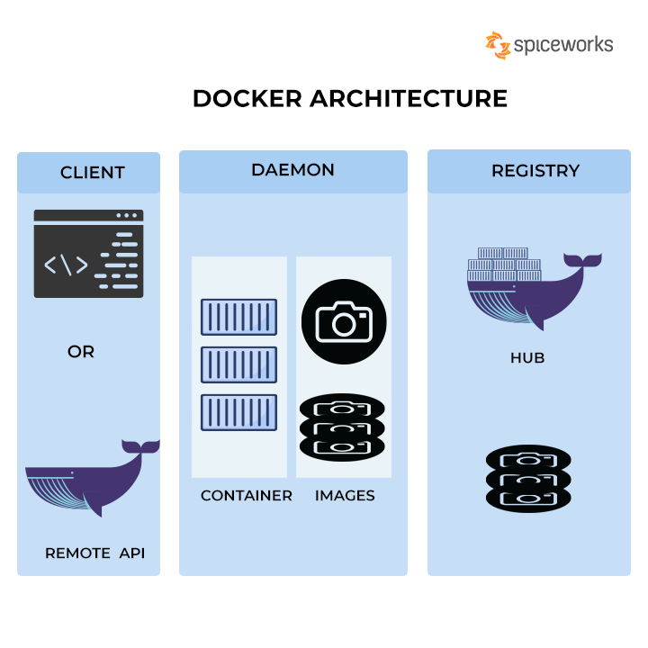
17. what is docker hub?
Ans: Docker Hub is a service provided by Docker for finding and sharing container images with your team.
18. what is docker image registry?
Ans: A Docker registry is a storage and distribution system for named Docker images. The same image might have multiple different versions, identified by their tags. A Docker registry is organized into Docker repositories , where a repository holds all the versions of a specific image.
19 how you delete file in git?
Ans: The easiest way to delete a file in your Git repository is to execute the “git rm” command and to specify the file to be deleted. Note that by using the “git rm” command, the file will also be deleted from the filesystem
20. how can you copy Jenkins from one server to another server?
- Ans: Install a fresh Jenkins instance on the new server
- Be sure the old and the new Jenkins instances are stopped
- Archive all the content of the JENKINS_HOME of the old Jenkins instance
- Extract the archive into the new JENKINS_HOME directory
- Launch the new Jenkins instance
- Do not forget to change documentation/links to your new instance of Jenkins :)
- Do not forget to change the owner of the new Jenkins files : chown -R jenkins:jenkins $JENKINS_HOME

21. how you do Jenkins pipeline job in your environment?
22. how you check free space in linux?
Ans: df-Ah
Df -ak
Df -am
24. how you delete a file in linux?
Ans: $rm filename

NTT DATA:
25.what is git rebase? Difference between git rebased and.. git merge?
Git merge is a command that allows you to merge branches from Git.
Merging is a common practice for developers. Whether branches are created for testing, bug fixes, or other reasons, merging commits changes to another branch. It takes the contents of a source branch and integrates it with a target branch.
Git rebase is a command that allows developers to integrate changes from one branch to another.
Git rebase compresses all the changes into a single “patch.” Then it integrates the patch onto the target branch. Unlike merging, rebasing flattens history. It transfers the completed work from one branch to another. In the process, unwanted history is eliminated.
Advocates of Git rebase like it because it simplifies their review process.

26.difference between ansible playbooks and roles?
Ans: Playbooks and roles are similar. Different at the same time. A playbook is a standalone file that Ansible can run that contains all of the information required to set a machine's state to what you expect. A playbook can contain variables, tasks, handlers, roles, and even other playbooks, all in the same file

27.how can u connect corporate data centre through aws?
Ans:- AWS Direct Connect enables you to securely connect your AWS environment to your on-premises data centre or office location over a standard 1Gb or 10Gb Ethernet fibre-optic connection. AWS Direct Connect offers dedicated high speed, low latency connection, which bypasses internet service providers in your network path.
28. what is IAM user in aws?
29. what is cmd and entrypoint in aws?
30.types of pipelines?
Ans: Declarative, Scripted.
31. artifact archive in Jenkins?
Ans: Archive the artifacts. Archives the build artifacts (for example, distribution zip files or jar files) so that they can be downloaded later. Archived files will be accessible from the Jenkins webpage.
JENKINS_HOME directory
By default, Jenkins archives artifacts generated by the build. These artifacts are stored in the JENKINS_HOME directory with all other elements such as job configuration files.

32. difference between docker image and layer?
Ans: Each layer is an image itself, just one without a human-assigned tag. They have auto-generated IDs though. Each layer stores the changes compared to the image it's based on. An image can consist of a single layer (that's often the case when the squash command was used).

33. difference between git rebase and git merge?
Ans: 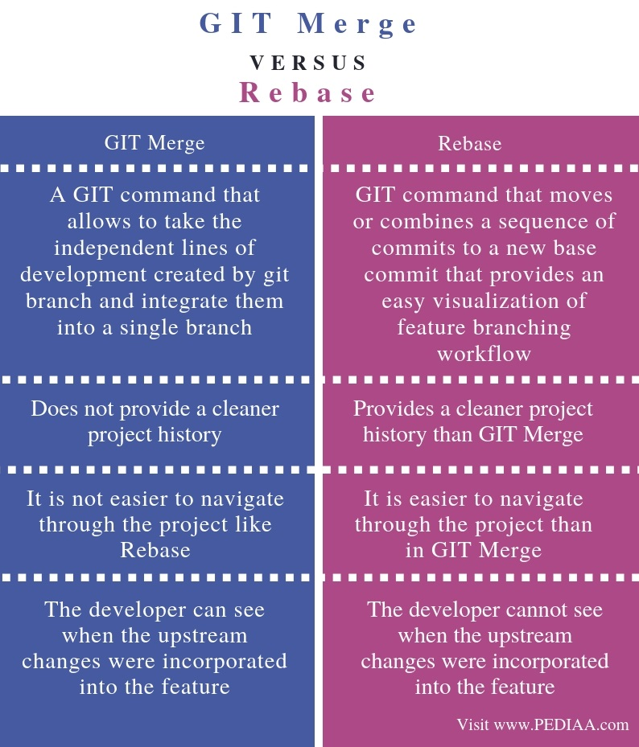
34. what is devops?
35. what is devops life cycle?
36. what are branching strategies in git?
37. types of Jenkins pipelins?
38. how to trigger pipeline?

Ans: Prerequisites
- Set up Jenkins as a continuous integration system in your Spinnaker deployment.
- Enable artifact support .

Adding a Jenkins trigger
- Create a pipeline .
- In the Configuration stage of your new pipeline, add a trigger .
- Select Jenkins from the Type menu, which brings up the following screen:
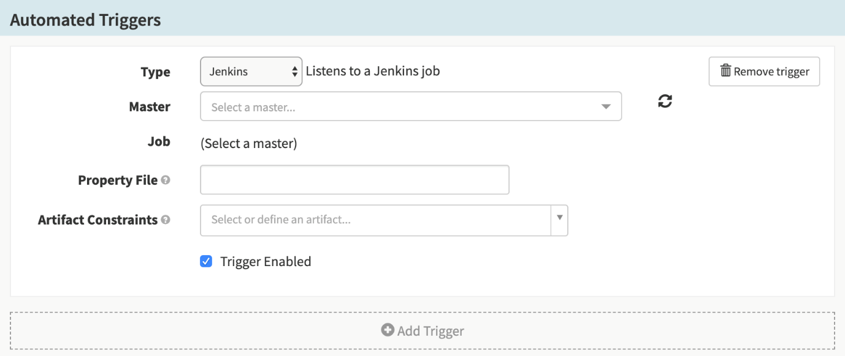
- Select a Jenkins master from the Master drop-down menu, then select a job from the Job drop-down.
- Add a property file, if desired. See the property files section of the Pipeline Expression Guide for more information about how to specify and use property files.

Build Artifacts

39. handlers in Ansible?
40. how you give security credentials in jenkins?
Ans: From the Jenkins home page (i.e. the Dashboard of the Jenkins classic UI), click Manage Jenkins > Manage Credentials. Under Stores scoped to Jenkins on the right, click on Jenkins. Under System, click the Global credentials (unrestricted) link to access this default domain. Click Add Credentials on the left.
Matrix based Security
41. what are tags in git?
42.difference between devops and agile?
Parru internal interview questions:
1.did you wrote any scripting in Jenkins?
Ans:shell scripting
2.there is a code .. and a change come in code now job should execute..? how wil you establish this?
3. any variable should run common in whole script?
4. u should create new agent?and attach new machine to our Jenkins?
5. how will you give permissions to user in Jenkins?
6. in a directory we should find out one particular word and how many times it is repeated?
7. git webhooks, API calls, get, post etc, and phython?
8. scenario there are two pipelines one pipeline is should always run only after first pipeline is passing?
9.how to put if condition
10. how to no of files count in a directory?
11.how to list of files in a directory?
12. how to create a file in a directory?
13. what is shared library?
14. we should access a file in one location in linux using python language in Jenkins?
15. how you take process list in linux?
16. what is grep command, awk and sed , find commands?
17 what is ps -ef command in linux?
18. What is api?
19. What is docker swarm?
Docker swarm is a container orchestration tool, meaning that it allows the user to manage multiple containers deployed across multiple host machines. One of the key benefits associated with the operation of a docker swarm is the high level of availability offered for applications.
20.what is docker xpose?

